2017上半年教师资格证面试真题及解析：初中英语(第三批)
初中英语《New school life》
一、考题回顾
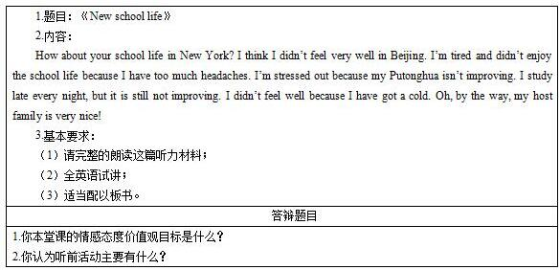

二、考题解析
《New school life》主要教学过程及板书设计
教学过程
Step1 Warming-up and lead-in
After greeting the students, the teacher shows a segment of the film St, Trinian's, which is about some trouble-making students, and invite the students to have a free talk about their headaches in the new semester.
Step2 Pre-listening
The teacher tells the story of John, the speaker, who is a new comer of Beijing, and shows several pictures of John’s school life to teach the new phrases “have a headache”, “stress out” and “get a cold”.
Ask students to predict the reasons why John feels bad in Beijing, any presumptions are encouraged.
Step3 While-listening
1. Fast-listening
Get students to listen to the tape for a first time to get the main idea of the listening material and think over the following questions:
Question1: Did John enjoy his school life in Beijing?
Question2: Is John’s Putonghua improving?
Question3: How is John’s host family?
2. Careful-listening
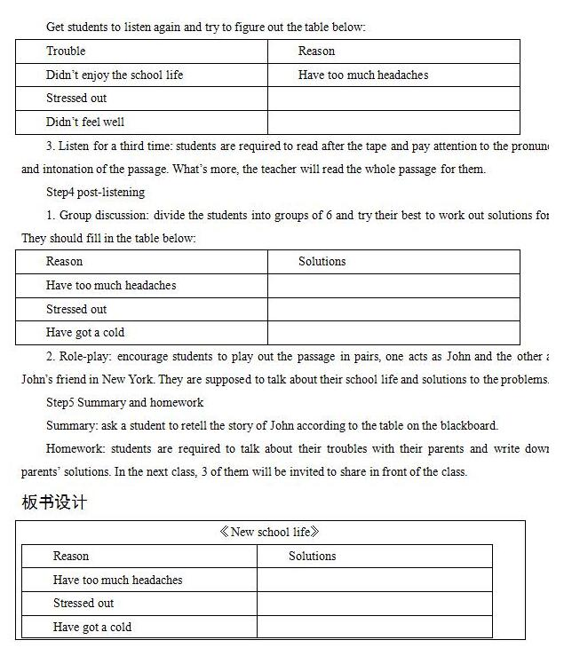
答辩题目解析
1.你本堂课的情感态度价值观目标是什么?
【参考答案】
我本次设定的情感态度目标主要有如下两个：一是学生能锻炼主动克服学习过程中所遇困难的能力，二是学生能够进一步加深其对英语学习的兴趣及动机。
2.你认为听前活动主要有什么?
【参考答案】
听前活动的主要作用在于让学生对所学材料内容有所准备，因而，老师可以采用以下几种方式：
(1)介绍相关的背景知识，用图片或是视觉影响吸引学生对听力材料的注意力，激发学生的观察能力和描述能力;
(2)提供一些词汇或相关问题，让学生预测所要听的材料内容;
(3)提出一些开放性问题锻炼学生的想象能力和分析问题的能力。

