2017上半年教师资格证面试真题及解析：高中英语(第三批)
高中英语《British and American English》
一、考题回顾
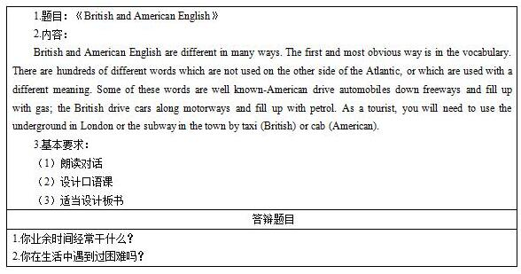

二、考题解析
《British and American English》主要教学过程及板书设计
教学过程
Step 1 Warming up and lead in
1. Play two speeches, one speech in British English and the other in American English.
2. Students will answer the questions: Are there any differences between the two speeches? Why there are so many differences?
3. After students think and make out the answer, teacher will point out the title of this lesson.
Step 2 Pre-listening
1. Listen to the tape of this lesson and find out the new words. Before listening, teacher will give some guidance about which part students will pay more attention to.
2. After listening to the tape, students will write the new words on the blackboard. Teacher will choose some students to guess the meaning of those words and direct them to make out the right answer.
Step 3 While- listening
1 The words obstacles have been cleaned, then teacher will play the tape for the second time. This time students will talk about the main idea of this passage.
2. Play the tape for the third time. This time teacher will play it sentence by sentence and students will repeat the passage word by word.
3. After repeating, students will find out the words with the same meaning but use the different style in British English and American English.
4. List more words with the same meaning but use the different style
5. Students should work in pairs. Teacher will choose some students to write their answer on the blackboard.
6. Talk about other kinds of English styles and their characteristics in groups and every group will chose a representative to describe their final result.
Step4 Post- listening
Review the new words use ask and answer methods
Students will work in pairs to make up dialogue. One student use British English and the other use American English style.
Step 5 Summary and homework
Review what we have learned together
Find out more differences between British and American English.
板书设计
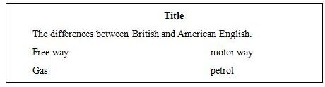
答辩题目解析
1.你业余时间经常干什么?
【参考答案】
我喜欢登山，好的身体是未来的保障。在登山的过程中我可以锻炼身体。我喜欢登山的第二个原因是在登山看风景的过程中我可以享受完全放松的感觉。还有，在登上山顶以后我可以享受胜利的感觉。
2.你在生活中遇到过困难吗?
【参考答案】
我在生活中确实遇到过一些困难，虽然这些困难不是很大。我仍然记得我第一次离开家去求学，我感觉很孤独而且不知道如何与那么多陌生人相处。但是我发现当我真正的去主动和他人交流并且在日常生活中善于帮助别人的时候我交到了一些真心的朋友。从那以后我再也没有感到孤独。
​

