2017上半年教师资格证面试真题及解析：初中英语(第一批)
初中英语《What are you going to be when you grow up?》
一、考题回顾
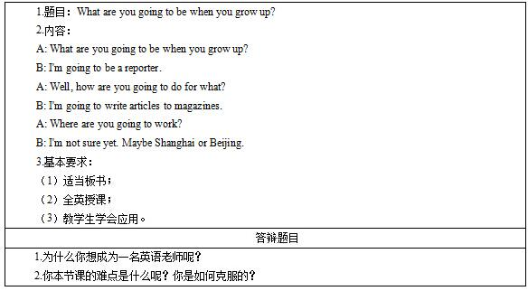

二、考题解析
《What are you going to be when you grow up?》主要教学过程及板书设计
教学过程
Step1 Warming-up:
Listen to a song, “Be what you wanna be”. And after listening, I will ask a question: what can you hear from the song? Yes, many professions, such as lawyer, doctor and so on. And then I will ask students, “ what do they want to be when they grow up” and ask some students to answer the question. And then I will tell students we can also say “what are you going to be when you grow up” and lead to today’s class.
Step2 Pre-listening:
I will show some pictures on the PPT, the first picture is about reporter and the second picture is about the article. I will write down the two words on the blackboard and then I will ask the students to read after me.
Step3 While-listening:
I will ask students to listen to the radio for the first time and then match the sentence with the picture on the PPT. The first picture is about the reporter, the second picture is about writing magazines and the third picture is about Shanghai.
Then I will ask students to listen to the radio for the second time and after listening, I will ask them to answer three questions on the blackboard, the first one is “What is he going to do when he grows up”, the second one is “how is he going to do for that” and the third one is “where is he going to work”.
I will ask students to listen to the radio for the third time and they need to read after the radio. And then I will divide the students into two groups, group A acts as A, and group B acts as B, and read the passage.
Step 4 Post-listening
We will play a game called “hot potato”. When the music begins to play, students need to pass the flower. And when the music stops, the student who is holding the flower need to answer the question about “what is he going to do when he grows up, how is he going to do for that or where is he going to work”.
And then we will have a group work, four students as a group and students need to make a survey about what is their group members going to be, how is he or she going to do for that and where is he going to work. Five minutes later, I will ask some groups to show their report.
Step5 Summary and homework
I will ask students to read the passage to summarize what we have learned today. After class, they need to search more information about the job they want to do.
板书设计
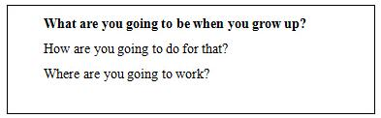
答辩题目解析
1.为什么你想成为一名英语老师呢?
【参考答案】
因为我的妈妈是一名老师，她为学生奉献的精神深深感动了我。她告诉我教师这个职业是非常伟大的，对于整个国家的意义重大。当面对学生那渴望知识的眼睛，能够帮助学生掌握知识，认识社会，见证他们一点一滴的成长和进步，你会为此感到欣慰和骄傲。所以我从小的愿望就是和妈妈一样成为一名老师。学习英语之后，我一直很喜欢英语，英语成绩一直不错，所以我想成为一名英语老师。在今后的工作中，我会继续深化自己的专业知识，掌握一定的教学方法和班级管理方法等，争取成为一名优秀的英语教师。
2.你本节课的难点是什么呢?你是如何克服的?
【参考答案】
这节课的难点是让学生把所学知识用于实际生活的表达中，学会阐述他们想做的工作以及他们决定怎么做。本节课的主要内容都是围绕重难点展开，花了大篇幅去讲解并且让同学理解具体意义，让学生体会其在现实生活中是如何应用的。并且通过一些图片描述让学生对其含义和使用范畴有更清晰的了解。通过组织班级游戏以及小组活动来让学生把句型用在真实情境中，游戏及小组活动能够吸引学生的兴趣，并且游戏和小组活动都是全班同学共同参与，这让全班同学都得到了练习，并且也能帮助老师检验学生对于所学知识的掌握程度，最终帮助学生攻克本节课的难点。

