2017上半年教师资格证面试真题及解析：高中英语(第四批)
高中英语《Computer》
一、考题回顾
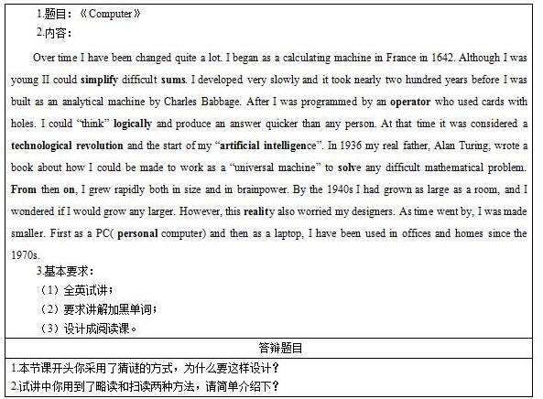

二、考题解析
《Computer》主要教学过程及板书设计
教学过程
Step 1: Warming up
Play a guessing game with students. These riddles are related to computer:
I am a machine. My shape is not large. I can help people calculate sum. Who am I?
I am a machine. I am very diligent and can help you do house work. Maybe I can talk to you in the future. Who am I?
Step 2: Pre-reading
Show a picture of prototype of computer and ask students to guess what this is.
Step 3: While-reading
1. Fast reading:
Read the whole passage quickly and find the time line of the development of Computers.
Invite one student to write it on the blackboard.
2. Detailed reading:
Ask students to scan the following questions, look up the new words in these sentences by themselves. And then ask several students to read loudly one by one according to the timeline and other students should circle the related information.
Q: What Can I do when I was young?
Q: When is the start of my artificial intelligence?
Q: Why did my designer become worried in 1940s?
After students find out the answers, I will ask them to guess the new words in their answers such as simplify and reality by telling them the prototype of the two words: simple and reality.
Step 4: Post-reading
1. Give them further information about the key words: simplify, reality.
2. Ask students to have a group discussion. List the advantage and the disadvantage of internet.
Step 5: Summary & Homework
1. Ask students to summarize the development of computer according to the timeline on the blackboard.
2. After class, please search some famous pieces of Shakespeare and write an small article of the development of Chinese.
板书设计
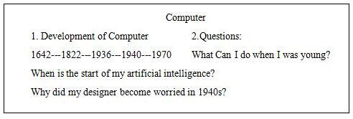
答辩题目解析
1.本节课开头你采用了猜谜的方式，为什么要这样设计?
【参考答案】
在课程导入部分，设计了猜谜的游戏，通过对计算机的描述，让学生猜测。这样做不仅可以激发学生学习的兴趣，还能为下面学习阅读篇章奠定基础。
2.试讲中你用到了略读和扫读两种方法，请简单介绍下?
【参考答案】
Skimming主要是用来抓住文章的主要要点的(chief points)，即找一篇文章的主旨大意或是文章的高潮，可通过抓住每一自然段的中心论点或中心句来判断一篇文章的大意。实际上，这就是一种整体阅读的方法。
Scanning为了寻找某一特定信息而大致地快速地浏览。在扫读之前要有明确的题目，根据题目找出定位词，然后再到文章里找相关信息，最后进行对比;我们没有必要从头到尾地、逐字逐句地阅读，只要找准定位词，快速地在文章内“扫描”出定位词，问题也就迎刃而解。

