2017上半年教师资格证面试真题及解析：小学语英语（第一批）
小学英语《A butterfly》
一、考题回顾
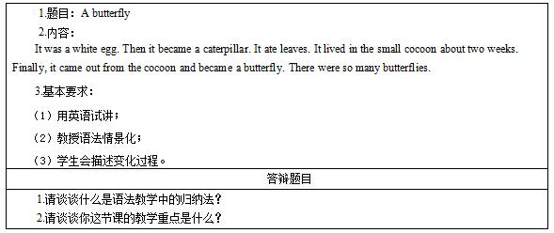
二、考题解析
《A butterfly》主要教学过程及板书设计
教学过程
Step1 Warming-up and lead-in
After greeting the students, I will play the song “The bear”, whose lyrics use the simple past tense, to the students. I will write down a segment of the lyrics on the blackboard and review the past form of some verbs, such as “look-looked”, “meet-met” and “say-said”, with the whole class.
Step2 Presentation
I will enjoy the strip pictures of butterfly growth with the whole class to introduce the simple past tense. I will ask students questions while watching the pictures. The questions are: “what was the color of the egg?”, “what did a caterpillar eat?” and “how long did the caterpillar live in the small cocoon?” By orders of strip pictures, the growth a butterfly is showed clearly, and time sequences are showed by “the first”, “then” and “finally”.
As the students answer these questions, answers are written down on the blackboard. I will invite students to work out the rule of the simple past tense. Simple past tense is usually used to talk about a completed action or state that occurred in the past, and to form this tense, one needs to add -ed to the end of a regular verb and remember the past forms of some irregular verbs.
Step3 Practice
1. Conversion task: students are required to converse the following simple present tense into simple past tense to better understand the new structure:
I usually eat an egg for breakfast.
I _____ an egg for breakfast yesterday morning.
People often live in houses.
John _____ in the small village for about two years.
Do you come to your grandma’s twice a week?
He _____ to see his grandma last week.
There are three people in my family.
There _____ many butterflies here 5 years ago.
2. Translation task: students are expected to translate the following Chinese into the corresponding English.
我妹妹早餐吃了一个橙子和一片面包。
约翰之前和他妈妈去逛了百货商场。
我上周买了一个新的文具盒。
Step4 Production
1. Group discussion: divide the whole class into groups of 6 and require them to describe the growth of a tree, at the same time, draw it into strip pictures. Three groups will be asked to have a presentation.
Filling blanks: students try to fill in the blanks below independently:
It _____ a small seed. Then it _____ a sapling after two weeks. Finally it _____ tall and _____ a large tree. There _____ so many big trees.
Step5 Summary and homework
Summary: invite two students to retell the growth of a butterfly with the help of strip pictures.
Homework: ask students to select pictures of their childhood and make a comparison between the present selves and the old selves.
板书设计
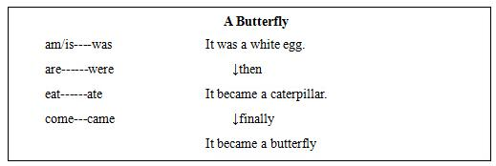
答辩题目解析
1.请谈谈什么是语法教学中的归纳法?
【参考答案】
先让外语学习者接触包含语法规则的真实上下文，通过学习大量例句，使学生形成一定程度的感性认识，进而对材料进行加工，最后再总结归纳出语法规则。
2.请谈谈你这节课的教学重点是什么?
【参考答案】
我本堂课的教学重点是一般过去时的用法。通过本堂课的学习，学生能够使用一般过去时谈论过去某个时间发生的动作，并能够熟知规则动词和不规则动词的过去式。
​

