2017上半年教师资格证面试真题及解析：小学语英语(第四批)
小学英语《Welcome to Africa》
一、考题回顾
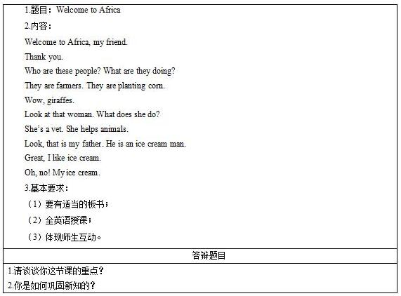
二、考题解析
《Welcome to Africa》主要教学过程及板书设计
教学过程
Step 1 Warming-up and Lead-in
1. Greeting the students with “nice to see you again”.
2. Ask about some students about their experiences of vacations in other countries.
Step 2 Pre-reading
Show students a picture of Africa on the PPT and ask some students what they can see in the picture.
The teacher will guide the students to think about the people and what they are doing in the picture.TheThe conclude their opinions and show them the new words of: farmer; vet; ice cream man.
Step 3 while-reading
1. Fast reading
The teacher asks the students to read the passage fast and try to answer the following questions according to the passage.
What is the main idea of the passage?
What do the people do in the passage?
What are the people doing in the passage?
2. Careful reading
The teacher asks the students to read the passage carefully and complete the True or False questions:
(1) The farmers are planting corn. ( )
(2) The vet doesn’t like animals. ( )
(3) My father is an ice cream man. ( )
Step4 Post-reading
1. Listen to the radio carefully and pay attention to the pronunciation and intonation.
2. Ask several students to role-play the conversation in groups of 2 in front of the class.
3. After their play, other students give their evaluations on their plays, and the teacher make a comment.
Step5 Summary and Homework
Summary: Ask some students what they have learned in this class and the teacher make a summary.
Homework:
1. Retell the conversation to your friends in your own words.
2. Search more jobs on the internet and share them in the next class.
板书设计
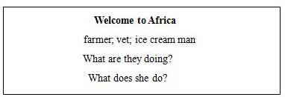
答辩题目解析
1.请谈谈你这节课的重点?
【参考答案】
这节课的重点是学生能够学会一些关于工作的词汇和如何来询问某人的职业，并且能够提升一些阅读技能，比如跳读和浏览的方式。
2.你是如何巩固新知的?
【参考答案】
巩固新知对于吸收本节课的重点内容是非常重要的。我在本节课的设计中，设计了角色扮演的活动，这样学生能在运用语言的过程中把所学新知转化为自己的语言，提高自己的综合语言运用能力，同时也加强了小组合作能力。

